
09 / 2002

Hello Fiero owners:

Brygida asked me to do the Newsletter this month too, so here it goes!

I am Alex Torres, the guy with the red & yellow Formulas. Many mods to mention but I’ll talk today about my Nitrous kit. First, below is a picture of our last meeting. Only Glen and me ☹. Can we call this a club? C’mon guys! We need to share more. What suggestions do you have for us to have better attendance??
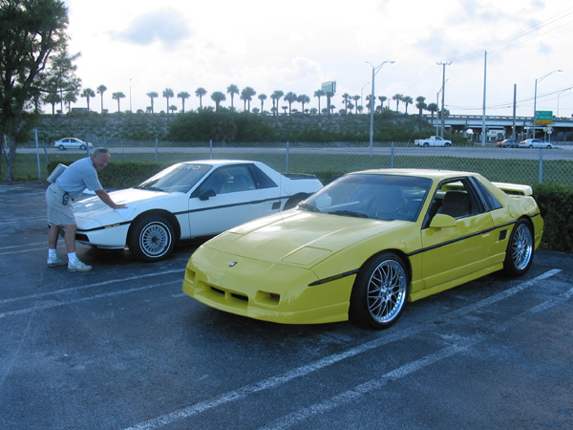
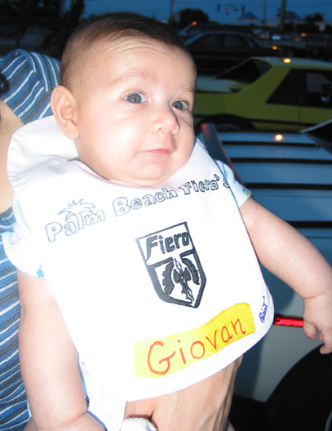
Here in the right we have a very active future member. Yes, even my 4 months old son Giovan attended the meeting and was welcome by a very nice WPB Fiero Club bib ☺ (Thanks to Glen and Mignon for that!) He was expecting to see more Fieros but….

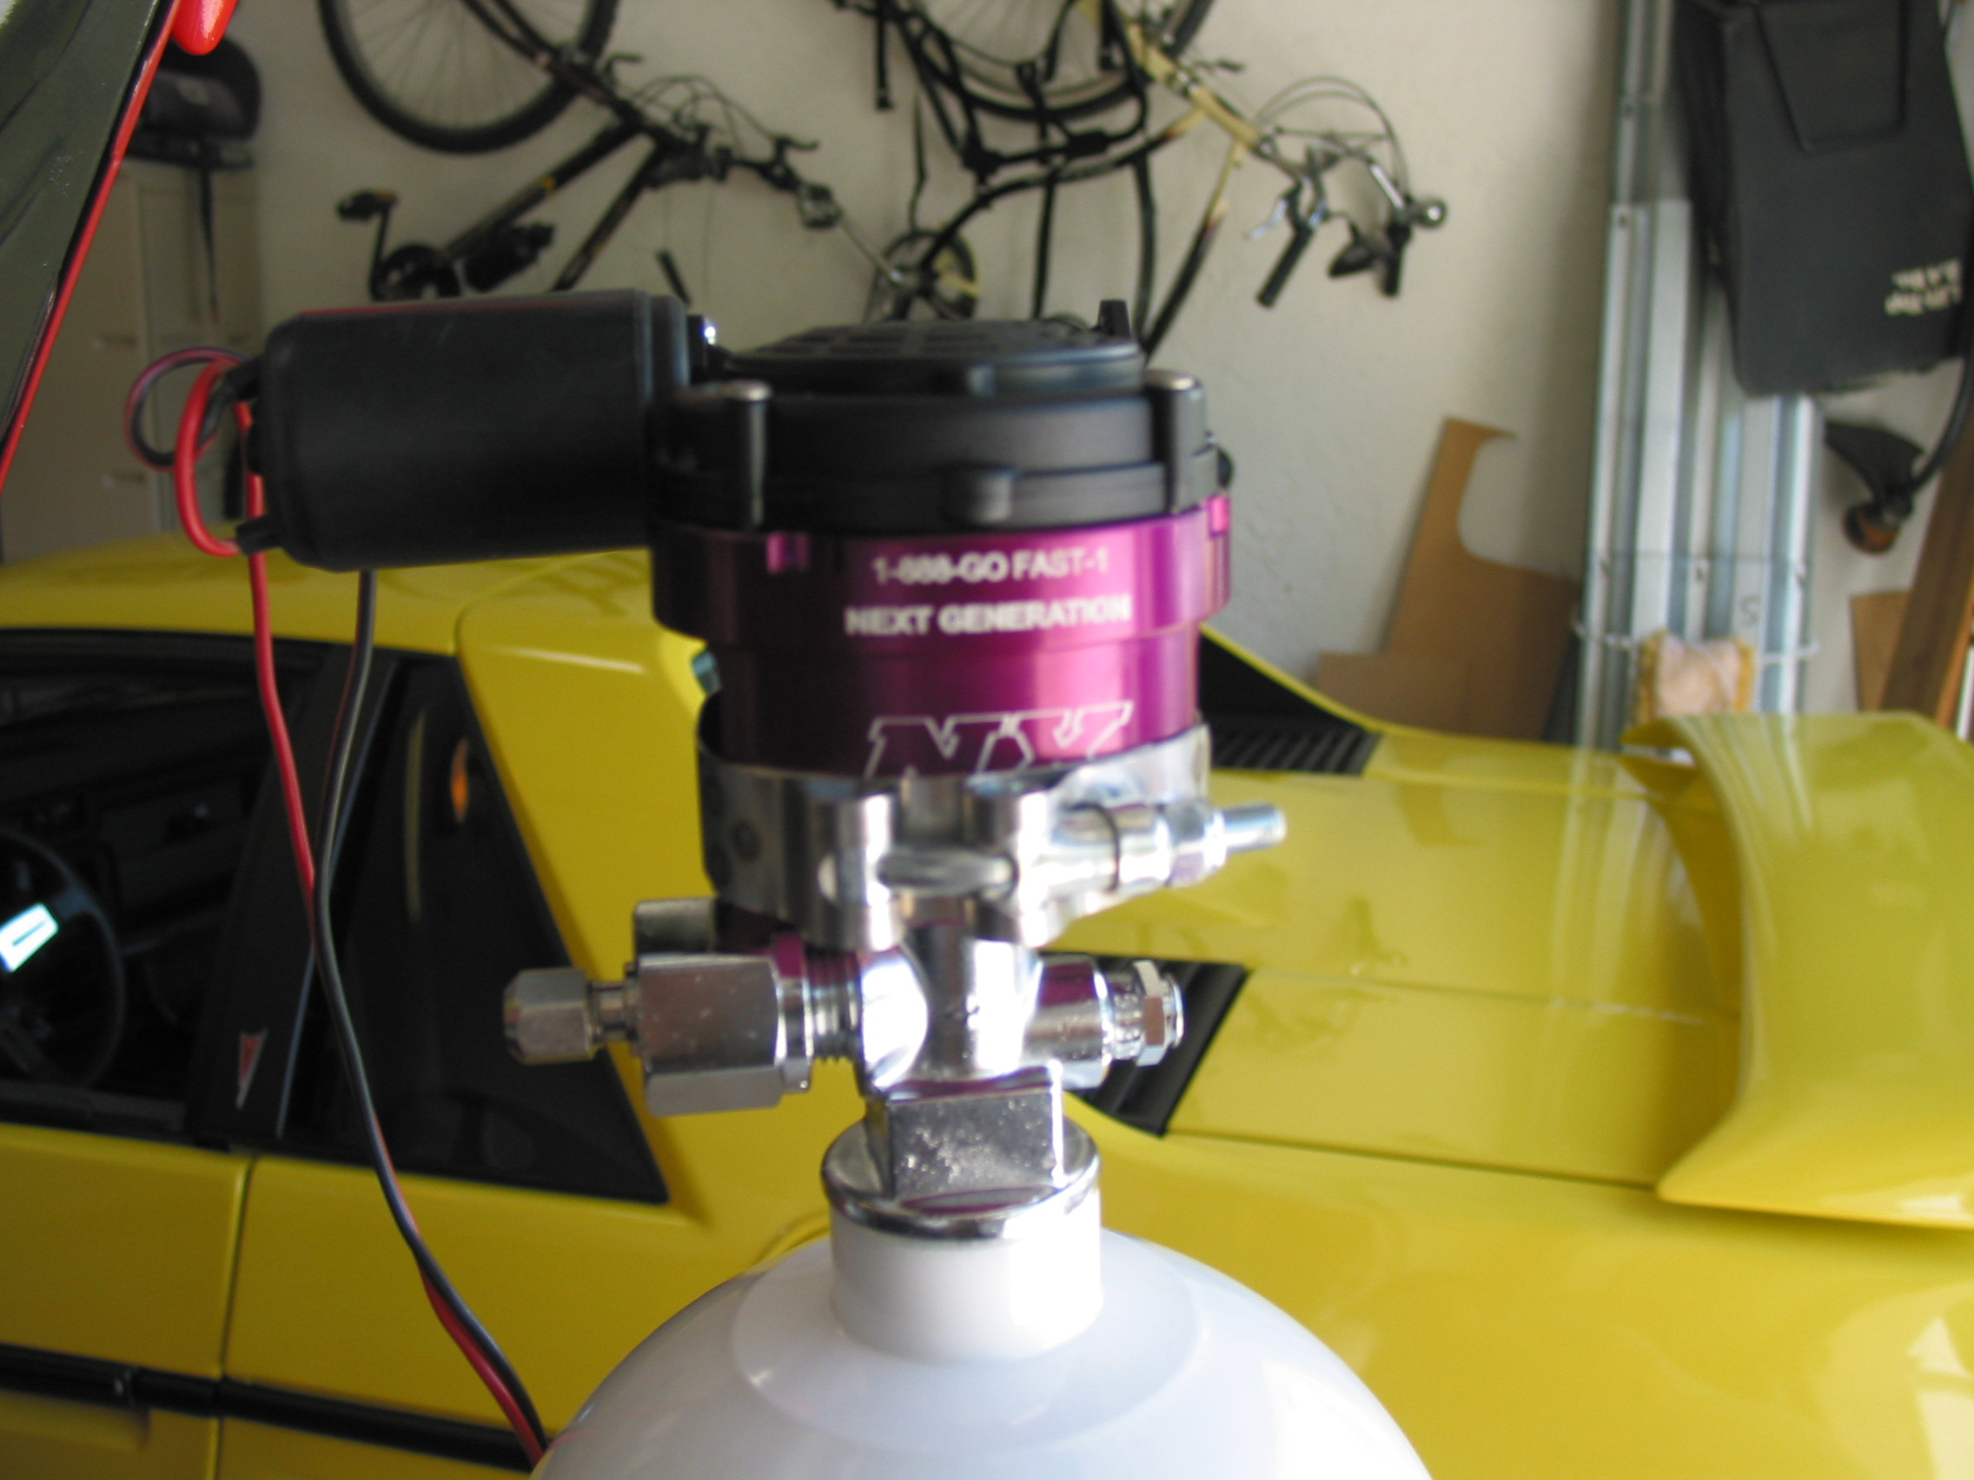
Ok. Let’s talk technical now. Many of you may be interested in adding some power to your beloved Fieros. The easiest and most cost effective way to do that to any car is to add a Nitrous Oxide (NO2) system kit to it. Many companies out there offer kits for our fuel-injected cars. Among them are, NOS, Nitrous Express (NX), Venom, ZEX, Edelbrock and many others. Some kits are what they call dry kits and some are wet kit. The main difference is that a wet kit will have a nozzle to add fuel together with the nitrous. In my case I selected the NX wet kit for my car. The advantages of a wet kit is that it is very hard to get a lean condition and that you don’t need to change the timing. The kit is very easy to install and you can add anywhere from 50 to 125 rear wheel horsepower! Up to now I have been using a 75HP shot in my car with excellent results. 0-60 time in my car dropped from 8.6s (V6 Auto) to 6.2s. That’s a great improvement! I’m planning soon to try a bigger shot.
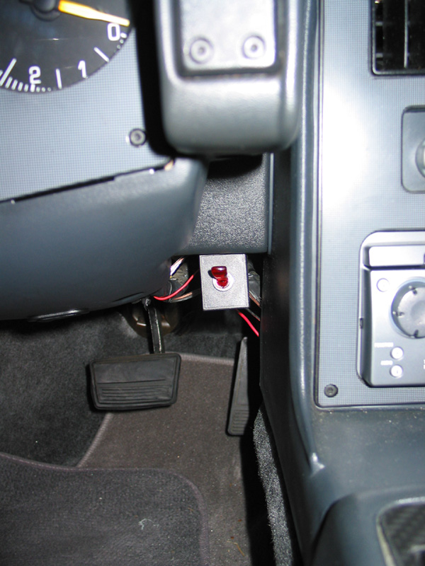
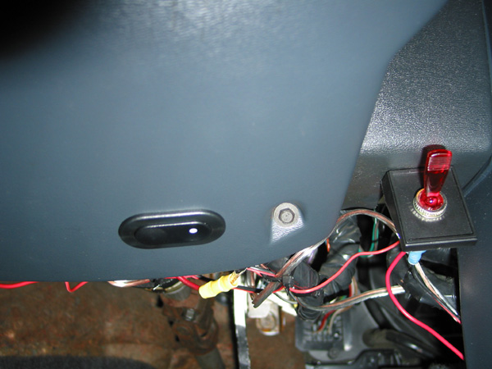
Now, one thing about nitrous is that in order to use it you need to go to the trunk and open the bottle. Not good for those stop light battles that may show up. In order to help with that we can install a remote bottle opener. The picture above shoes how one of this thingies look. It attaches to the bottle and then you route two cables to a switch in the cabin. In the other two pictures you can see my two nitrous switches. The toggle red switch is to arm the nitrous system. The other black switch is for the remote bottle opener. Installed in those locations it is very hard to spot them from outside the car but very easy to reach for your usage. Now you are ready for any instance when some of those ricers or Mustangs show up next to you. Ta da!!1 Surpriiissse! If you want more info in this topic please do not hesitate to drop me a line. C’ya!

We need Newsletter input! Please e-mail Brygida with your article.

http://pbfieros.tripod.com Thanks Alex for your input.

